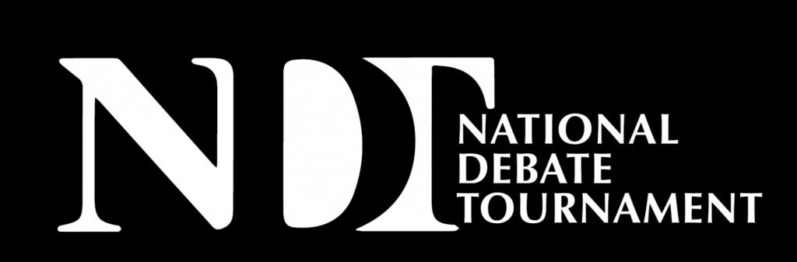

LAURENCE H. TRIBE DISTINGUISHED ALUMNI AWARD
About Laurence Tribe: Laurence Tribe was a member of the Harvard team that won the National Debate Tournament in 1961 and coached the team which won the 1969 National Debate Tournament. Professor Tribe is someone who embodies the values and principles of the debate community. He has demonstrated extraordinary service to the field of law, society, and humanity. Professor Laurence Tribe is currently the Carl M. Loeb Professor at the Harvard Law School. During his legal career he had argued more than thirty-five cases before the United States Supreme Court. Professor Tribe is the author the widely cited scholarly text, American Constitutional Law, and a leader in that field of study.
About the Tribe Award: The Laurence H. Tribe Distinguished Alumni Award will recognize a National Debate Tournament Alumnus who has used their debate training to make significant contributions to their profession, to society or to humanity.

Name of Nominee: Click or tap here to enter text.
Nominator: Click or tap here to enter text.
Briefly describe the nominee’s participation in the National Debate Tournament:
Click or tap here to enter text.
Briefly describe how the nominee has utilized their debate experience to advance their career :
Click or tap here to enter text.
Briefly characterize the nominee’s contributions to their profession, to society and to humanity:
Click or tap here to enter text.
Provide any additional information you believe would be helpful to the selection committee:
Click or tap here to enter text.

Please Complete this form and email to kleeper@augusta.edu by March 1, 2022.
We are grateful for your nomination.

