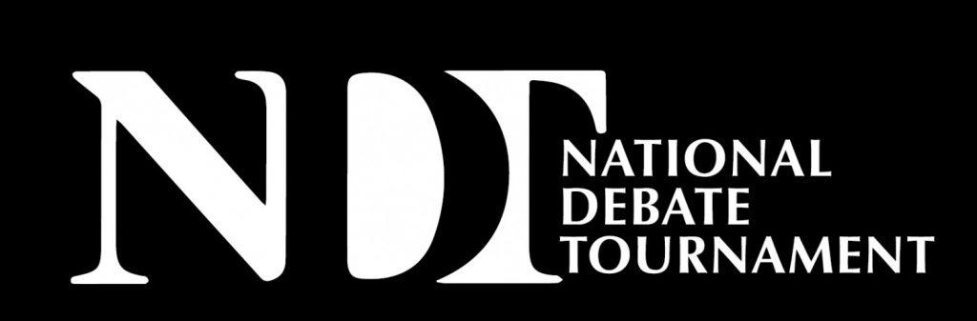

ROSS K. SMITH COACH OF THE YEAR AWARD
About Ross Smith: Ross Smith was the Director of Debate at Wake Forest University for over 25 years, coaching two National Debate Tournament Champions (1997 and 2008), two National Debate Tournament runners-up (2006 and 2009), the Rex Copeland Award winner in 1995, and the Top Speaker in 1988. He was the recipient of the George Ziegelmueller Coaching Award in 2009. He was a long-time member of the NDT committee and was an energizing force in efforts to innovate debate practice and to make intercollegiate debate more inclusive. Smith was active in efforts to encourage debate practitioners to be more engaged in questions of public deliberation and public policy.
About the Ross Smith Award: The coach of the year award was named in honor of Ross K. Smith in 2009. It is intended to recognize lifetime achievement in coaching intercollegiate debate. Lifetime achievement is measured based on the characteristics exemplified by the awards’ first recipient, Dr. Anabel Hagood of the University of Alabama.
The four characteristics of achievement are:
1) a consistent record fielding nationally competitive teams
2) a consistent record as a top judge
3) contributions to the evolution of the debate field
4) the intangible: taking debate outside itself.

Name of Nominee: Click or tap here to enter text.
Nominator: Click or tap here to enter text.
Briefly describe the nominee’s consistent record of fielding nationally competitive teams:
Click or tap here to enter text.
Briefly describe the nominee’s consistent record as a top judge:
Click or tap here to enter text.
Briefly characterize how the nominee’s work has contributed to the evolution of the debate field:
Click or tap here to enter text.
Briefly characterize how the nominee has encouraged debate to think about itself differently:
Click or tap here to enter text.
Provide any additional information you believe would be helpful to the selection committee:
Click or tap here to enter text.

Please Complete this form and email to kleeper@ku.edu by March 1, 2023.
We are grateful for your nomination.

