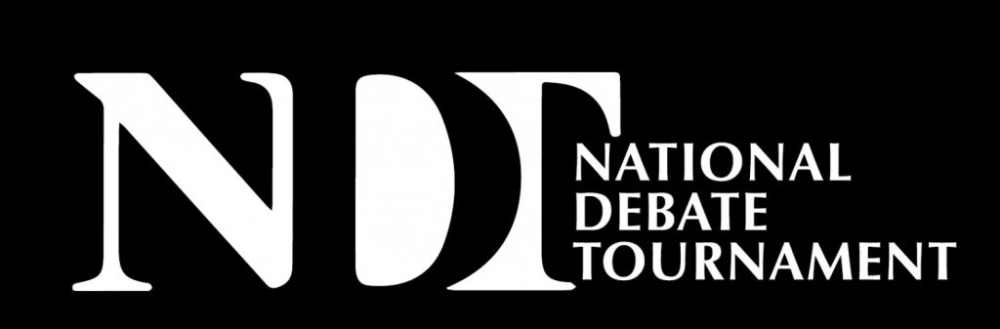

DR. GEORGE W. ZIEGELMUELLER AWARD FOR EXCELLENCE IN EDUCATION
About George Ziegelmueller: George W. Ziegelmueller earned a PhD. In Speech from Northwestern University in 1958. He was the Director of Forensics at Wayne State University for over 30 years. Over the course of that career, he provided leadership as president of Delta Sigma Rho-Tau Kappa Alpha and the American Forensic Association, and editor of the Central States Communication Association’s Journal. He was named the American Forensic Association’s Distinguished Member in 1981.
Dr. Ziegelmueller was a highly regarded and deeply dedicated educator-both to his own students and to the thousands of students he judged and mentored over the years. His Argumentation and Advocacy text was nationally recognized as the standard of excellence in debate pedagogy. In 2000, The Carnegie Foundation for the Advancement of Teaching named him Michigan Professor of the Year.
The Ziegelmueller Award: Named for George Ziegelmueller, this award was endowed by the Wayne State Debate Alumni. It recognizes individuals who have distinguished themselves in the communication profession while coaching teams to competitive success. Recipients should reflect Dr. Ziegelmueller’s commitment to academic excellence, excellence in debate pedagogy, and commitment to students’ personal and professional development.
Name of Nominee: Click or tap here to enter text.
Nominator: Click or tap here to enter text.
Briefly describe how the nominee has demonstrated a commitment to academic excellence:
Click or tap here to enter text.
Briefly describe how the nominee has demonstrated a commitment to excellence in debate pedagogy:
Click or tap here to enter text.
Briefly describe how the nominee has demonstrated a commitment to the personal and professional development of students:
Click or tap here to enter text.
Describe any leadership and service the nominee has provided to the community:
Click or tap here to enter text.
Provide any additional information you believe would be helpful to the selection committee:
Click or tap here to enter text.

Please Complete this form and email to kleeper@ku.edu by March 1, 2023.
We are grateful for your nomination.

