**American Forensic Association**

**Business Meeting**

November 20, 2024, 6:00-7:00 (Central)

Online Zoom Meeting

<https://missouristate.zoom.us/j/86431066935>

Meeting ID: 864 3106 6935

**AGENDA**

1. Approval of agenda and minutes
2. Welcome
3. Reports from Sponsored and Affiliate Organizations & National Council Officers:
   1. NST
   2. NDT
   3. NPDA
   4. Treasurer
   5. Executive Secretary
   6. Vice-President
   7. President
4. Reports from standing committees
   1. Finance
   2. Professional Development and Support
      1. DSR-TKA Lifetime Award
      2. Distinguished Service Awards
   3. Educational Development and Practices
   4. Research
      1. Rohrer Research Award
      2. Brockriede Research Grant
      3. Outstanding Dissertation Award
   5. Publications
   6. Nomination
5. New business
6. NCA affiliate discussion
7. Good of the Order

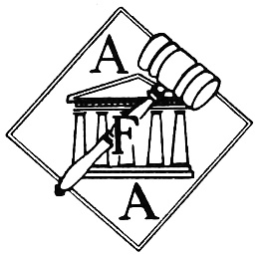

Follow us at:

<https://www.americanforensicsassoc.org/>

Facebook: @AmericanForensicAssoc

Twitter: @ AmericanForens1