American Forensic Association
Business Meeting
December 2, 2025
Online Zoom Meeting
https://missouristate.zoom.us/j/85282808332

AGENDA
- Approval of agenda and minutes

- Welcome

- Reports from Sponsored and Affiliate Organizations & National Council Officers:

  - NST
  - NDT
  - NPDA
  - Treasurer
  - Executive Secretary
  - Vice-President
  - President

- Reports from standing committees
  - Finance
  - Professional Development and Support
    - DSR-TKA Lifetime Award
    - Distinguished Service Awards
  - Educational Development and Practices
  - Research
    - Rohrer Research Award
    - Brockriede Research Grant
    - Outstanding Dissertation Award
  - Publications
  - Nomination

- New business

- Good of the Order

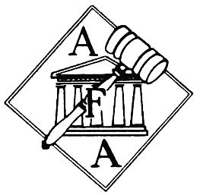

Follow us at:
https://www.americanforensicsassoc.org/
Facebook: @AmericanForensicAssoc
Twitter: @ AmericanForens1

